Student’s name | …………………………………………………….…… | Grade | 3
Subject | Computer | Week No. | 10
Lesson Title | Spreadsheet | Unit
Worksheet No. ( 10 )

Question A: Write the correct name of each part.

Check List | Menu Card

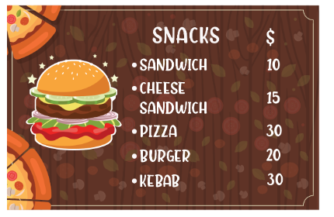
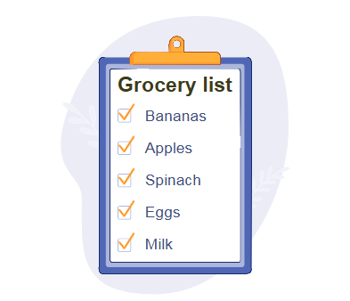
Good Luck

